



**A DATAbase application for monitoring Feed Phosphates Sales**

**OCP’s SPSS Strategic Business Unit**

**Supervised by :**

* **Prof.Karima Echihabi**
* **TA Khaoula**
* **TA Ilias**





Introduction

1.About our project . 2. Team Responsabilities 3. Challenges & Lessons Learned 4. Conclusion

**Summary**

1. **Introduction**
2. **About our project** 
   1. **First Page: Login and Register**

**2.2. Admin Dashboard**

**2.3. Charts**

**2.4. Export to CSV**

1. **Team Responsibilities**
2. **Challenges & Lessons Learned** 
   1. **Challenges faced**
   2. **Lessons learned**
3. **Conclusion**



**Introduction**

1. About our project
2. Team Responsabilities 3. Challenges & Lessons learned 4. Conclusion



“

##### Introduction

“

The purpose of this project was to develop a comprehensive database application to address the inefficiencies and challenges faced in monitoring feed phosphates sales at **OCP's SPSS Strategic Business Unit (SBU)**. The current process relied on an Excel file to manage sales data, which proved to be inefficient, error-prone, and hindered productivity. With the involvement of multiple users from different departments, including sales, logistics, and sales operations, the need for a centralized and streamlined system became evident.

The existing Excel-based system posed several challenges in effectively managing and tracking critical information such as customer orders, product demand, pricing, and shipment details. The lack of a centralized system resulted in difficulties in accessing and analyzing data, leading to delays, errors, and decreased productivity. Moreover, the involvement of multiple users added complexity to the process, making it challenging to ensure data integrity, security, and appropriate access permissions for each department.

To address these challenges, the project aimed to **develop a robust database management system specifically tailored to the requirements of OCP's SPSS SBU.** The system would provide an easy-access platform for users to store and retrieve data efficiently. Each user would have limited permissions based on their departmental requirements, ensuring that they could only access and modify the entries relevant to their specific responsibilities. By implementing such user permissions, data integrity and confidentiality would be maintained while improving overall efficiency.

One of the key requirements of the project was to provide **ready-to-use commands for data visualization**. The database application would enable users to generate reports and visualize sales data, allowing for a better understanding of sales trends, customer behavior, and product demand. This feature would empower the organization to make data-driven decisions, optimize pricing strategies, and enhance overall sales operations.proud of the **OCP team.**

Additionally, the project recognized the dynamic nature of sales transactions. The fillable entries in the database application were designed to adapt to the status of each transaction. This flexibility ensured that the appropriate fields were available for users to input the necessary information, capturing the transaction's current state accurately.

By streamlining the sales operations and optimizing the supply chain process, the successful implementation of the database application was expected to have significant benefits for **OCP's SPSS SBU**. The system would improve data accessibility, accuracy, and data visualization capabilities, enabling the organization to make informed decisions, better manage pricing strategies, and meet customer demands more effectively. Ultimately, this project aimed to contribute to the overall profitability and success of **OCP's SPSS SBU.**

Introduction

1. **About our project**
2. Team Responsabilities 3. Challenges & Lessons learned 4. Conclusion



##### About our project

“

“

The project's objective was to implement a database management system to efficiently manage sales data for **OCP's SPSS SBU.** The sales data, previously stored in an Excel file, posed challenges in managing and **tracking customer orders, product demand, pricing, shipment details, and related information.** The lack of a centralized system and the involvement of users from different departments, including sales, logistics, and sales operations, further exacerbated the difficulties.

The project aimed to address these issues by providing an **easy-access platform for** data storage and retrieval, limited user permissions based on departmental needs, ready-to-use commands for data visualization, and dynamic fillable entries based on transaction status. It will include various features to enhance data accessibility, security, and visualization.

* 1. **First Page: Register and Login**





**Register & Login**

**Register :**

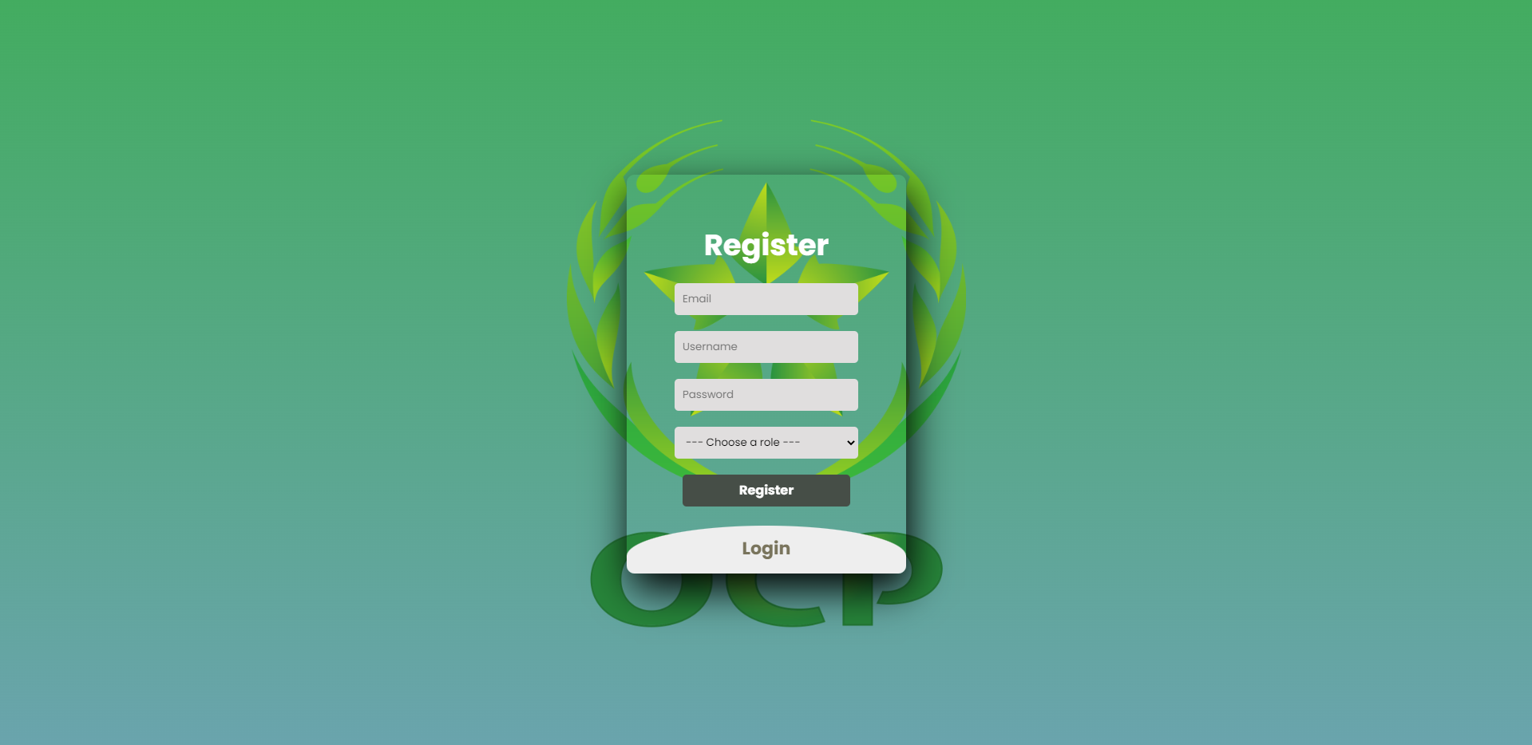

**Login :**



These two screenshots represent the **first page** of the platform, which includes a **login and register** functionality.

It includes a **form for user registration** and another **form for user login**. The registration form asks for the user's **email, username, password, and role, allowing them to choose from a dropdown menu with different options (Admin , Sales, Logistics, ADV)** and then have an access to the platform's features. The login form asks for the user's email and password. Both forms have corresponding buttons to submit the data.

**Register Error Handling:**



**The register error handling** on this platform involves checking for error messages and displaying appropriate feedback to users :

1. User submits registration details (email, password, username, etc.).
2. The server-side code checks if the email or username is already registered in the database.
3. If the email or username is already taken, an error message is displayed, indicating that the email or username is already in use.
4. If the email and username are available, the server validates the other registration details (password strength, required fields, etc.).
5. If any validation fails, appropriate error messages are displayed, indicating the specific validation errors.
6. If all the registration details are valid, the user is successfully registered and can log in.

**Login Error Handling:**



**The login error handling** on this platform involve checking for error messages and displaying appropriate feedback to users

1. User submits login credentials (email and password).
2. The server-side code validates the input and checks if the email exists in the database.
3. If the email does not exist, an error message is displayed, indicating an incorrect email.
4. If the email exists, the server checks if the provided password matches the one associated with the email.
5. If the password is incorrect, an error message is displayed, indicating an incorrect password.
6. If the login credentials are valid, the user is logged in successfully.
   1. **Admin Dashboard Page**

When selecting **”Admin"** from the drop-down menu, it redirects to the **Admin Dashboard page**. On this page, the admin is granted access to edit the database view with three available options:

1. **Add Row:** This option allows the admin to add a new row to the database. It typically opens a form where the admin can input the necessary data for the new row and submit it to be added to the database.



1. **Edit a Row:** This option enables the admin to modify an existing row in the database. It usually presents a list or search functionality to locate the desired row, and upon selection, displays a form or editable fields where the admin can make the necessary changes. After updating the row, the changes are saved to the database.
2. **Take a Look:** This option allows the admin to view the contents of the database without making any modifications. It presents the database in a readable format, such as a table.

These **three actions** provide the admin with the ability to manage and manipulate the data within the database through the Admin Dashboard page, offering flexibility and control over the database's content.





**Admin**

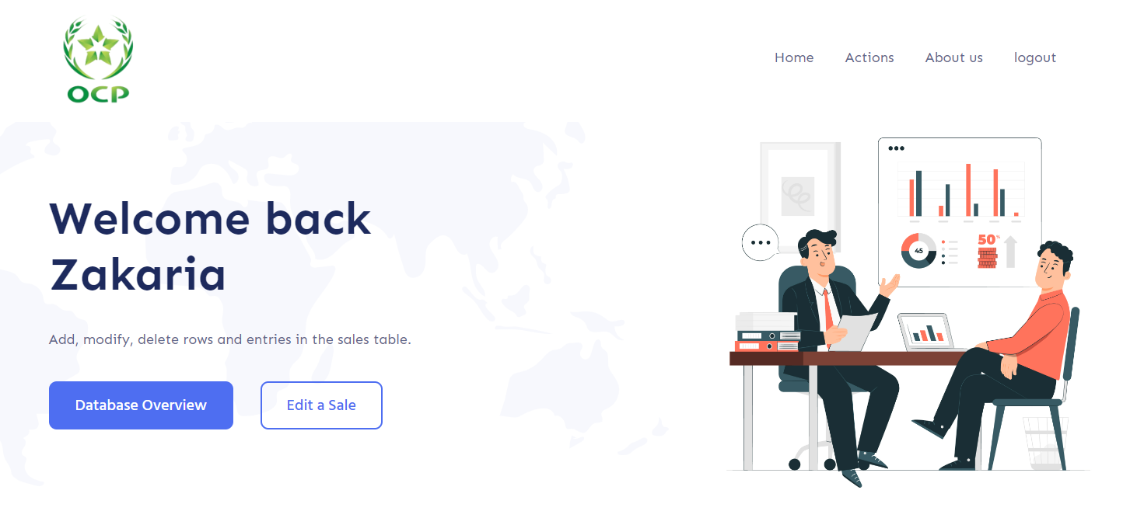

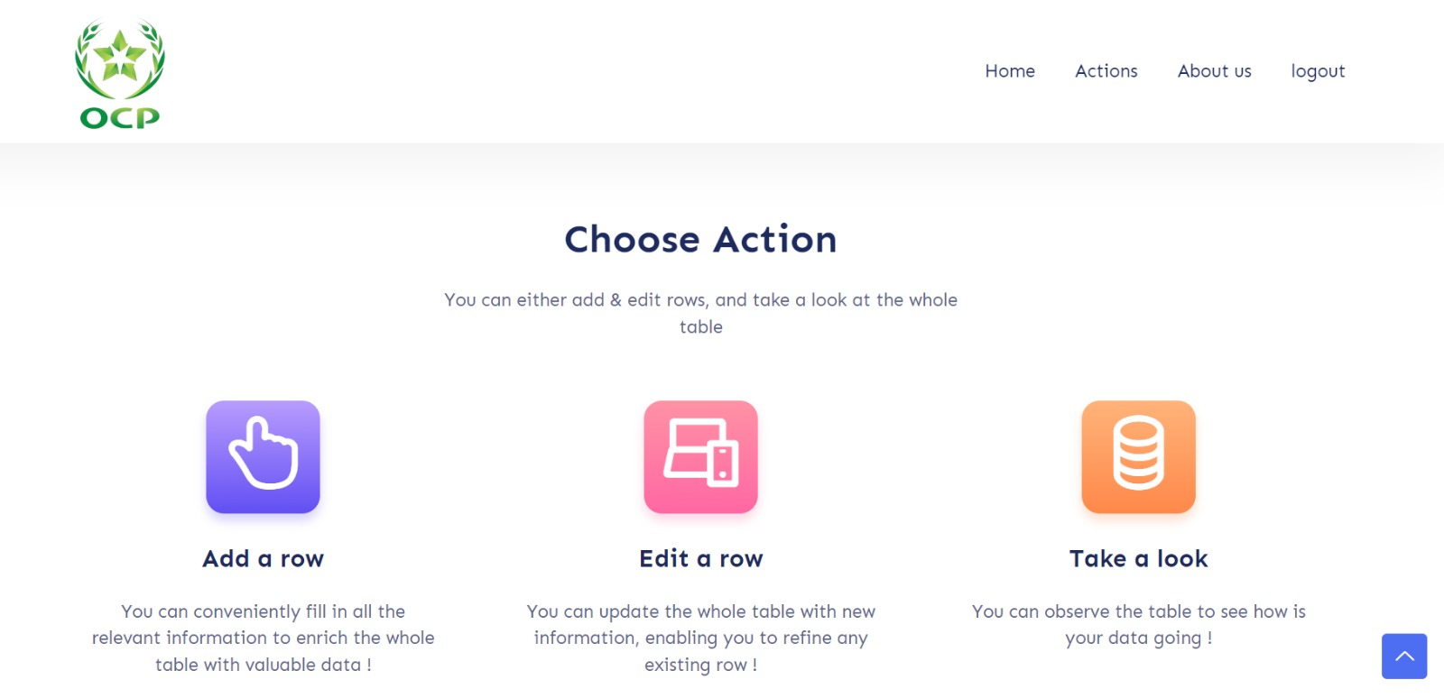

**Add Row Page**

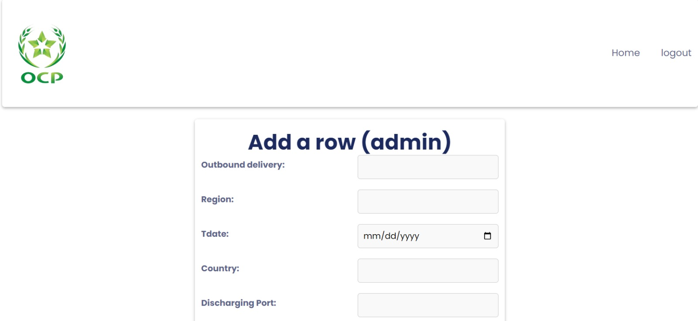

In the **"Add Row"** page for admin, the admin is presented with blank fields to enter the following information:

**Outbound Delivery**: This field is used to specify the outbound delivery which is the unique identifier of each transaction.

**Region**: The admin would enter the region associated with the new row. It is used to specify the region of the seller.

**Tdate:** This field represents the date of transaction.

**Country:** The admin would specify the country associated with the new row. It specifies the country of the destination port.

**Discharging Port:** This field refers to the name of the final destination port.

By filling in these blanks with the required information, the admin can add a new row to the database, incorporating the provided details for outbound delivery, region, Tdate (date), country, and discharging point.

**Edit Row Page**

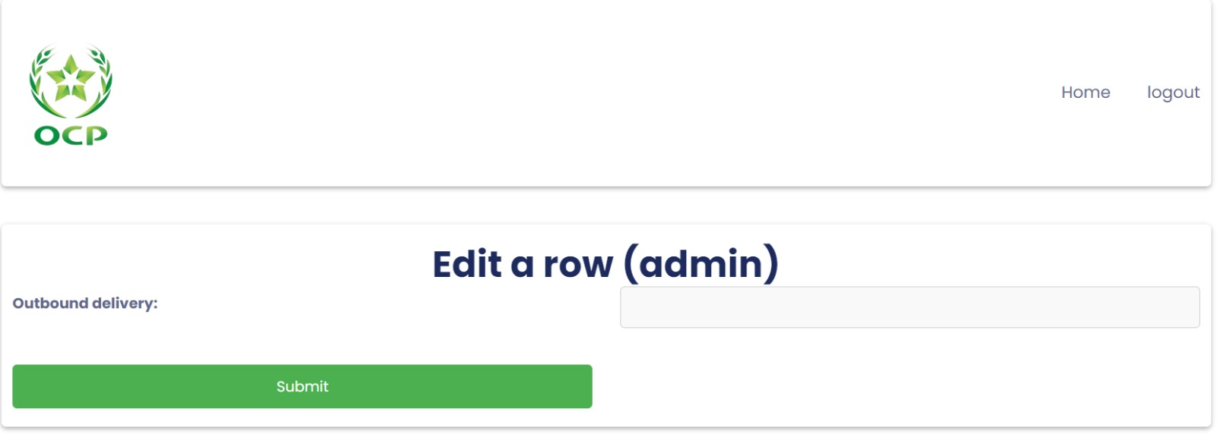

In the **"Add Row"** page for admin, the admin should enter the **Outbound Delivery** .Then, he would be directed to the following page in order to feed the page with more details.

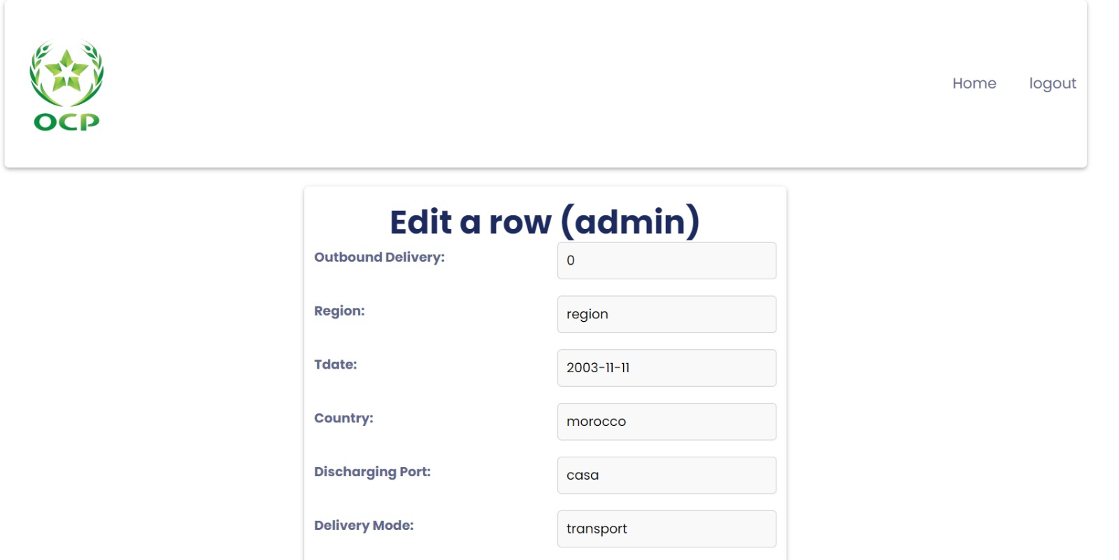

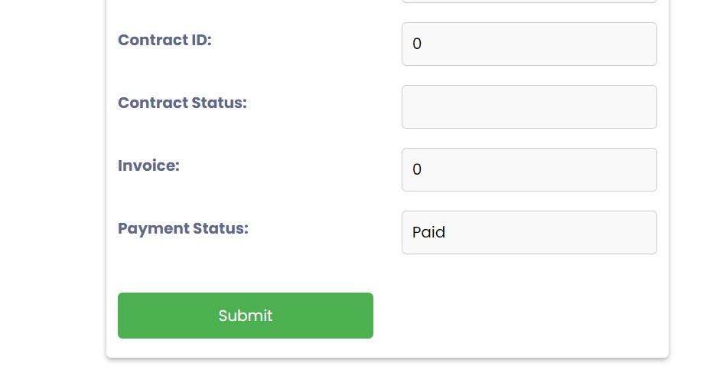

In the **"Edit a Row"** page for admin, the admin is presented with blank fields to enter the following information:

**Outbound Delivery**

**Region**

**Tdate**

**Country**

**Discharging Port:** This field refers to the name of the final destination port.

**Delivery Mode:** The admin would specify the type of delivery(vessel, truk, container, etc…)

**Contract Id:** Specifying the Id of the contract between the customer and the OCP company

**Contract Status :** This field is used to represent the status of the contract between the customer and the company(OCP).

**Invoice**

**Payment Status:** Either paid or not paid.

**Take a look**

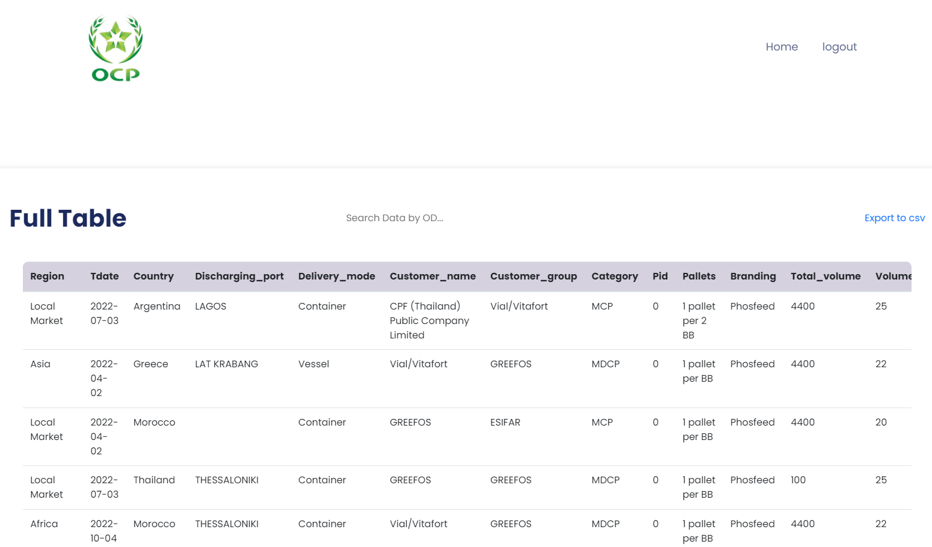

In the **"Take a Look"** option, the admin is granted access to view the full database. This typically includes displaying the entire database table, allowing the admin to see all the existing rows and their corresponding data.

* 1. **Charts**



**Charts**

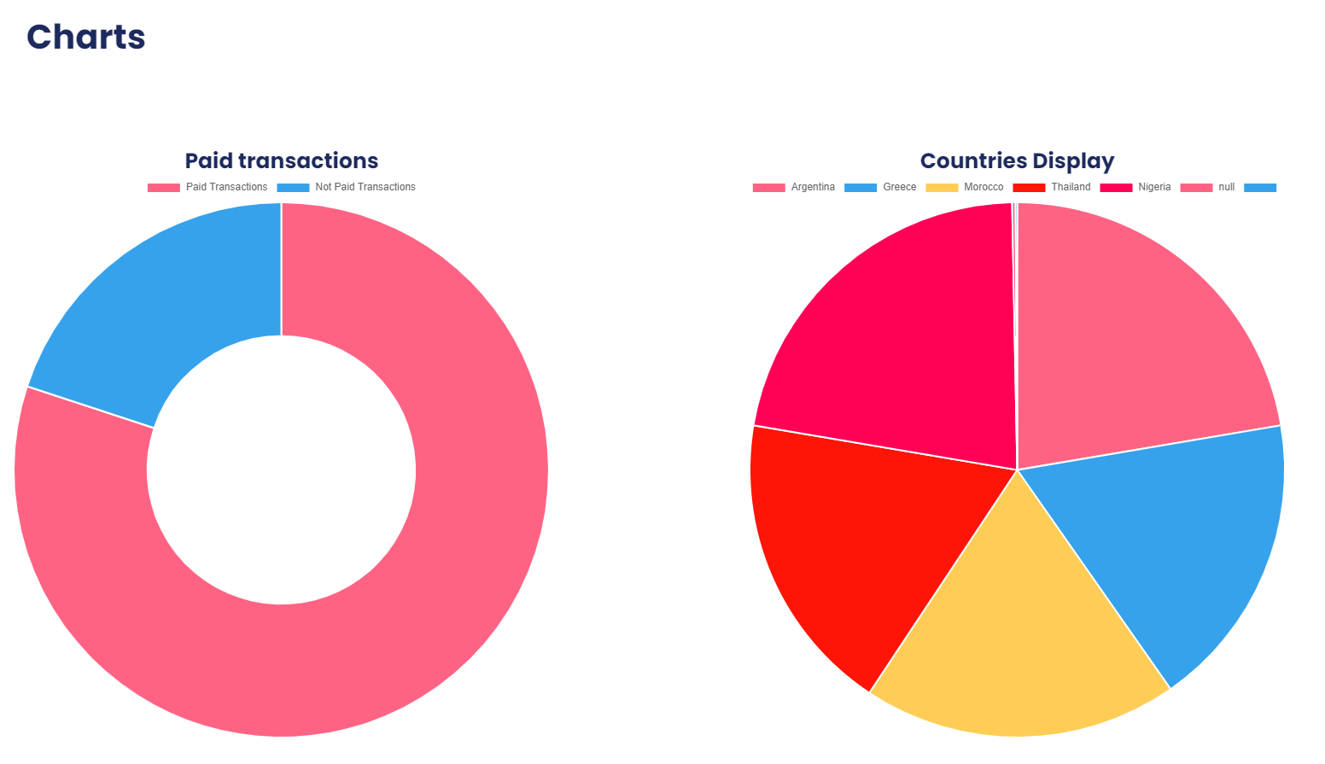

In addition to providing the option to view the full database, the platform also offers **charts** to facilitate data analysis and eliminate the need for the user to manually review the entire database. These charts present visual representations of the data, enabling the user to quickly grasp key insights and trends.

* 1. **Export to csv :**

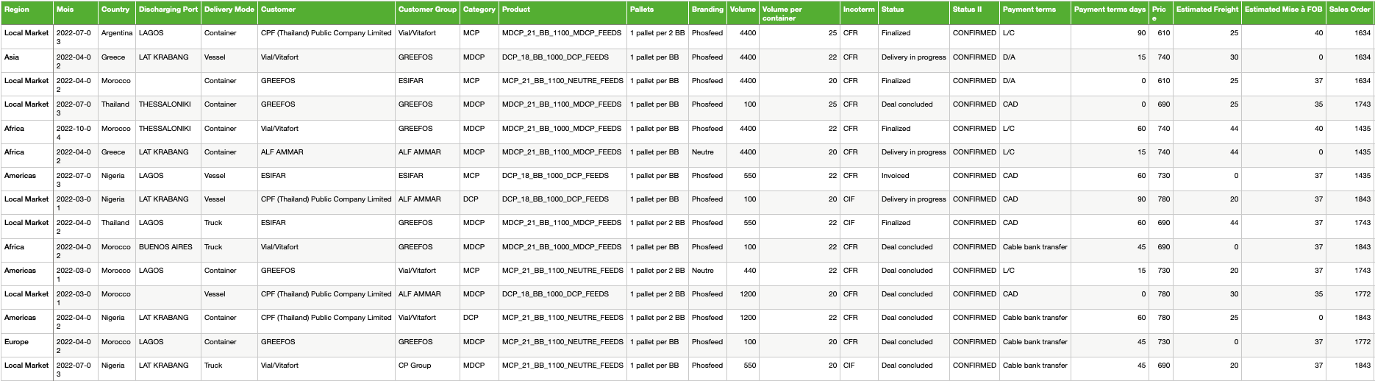

In addition to providing with charts for data analysis, the platform also offers the capability to export the full database view to a **CSV** (Comma-Separated Values) format. This feature allows to download the complete database information in a structured and easily readable format.

 Introduction 1.About our project **2.Team Responsibilities** 3.Challenges & Lessons learned. 4.Conclusion



##### Team Responsibilities

**Team Responsibilities:** The project team consisted of four members:

* BELMOUDDEN HAJAR
* CHOUKRI ZAKARIA
* HANIF MAHA
* YOUSS AYMAN

Each team member had specific **responsibilities:**

* BELMOUDDEN HAJAR:.
* CHOUKRI ZAKARIA:.
* HANIF MAHA:.
* YOUSS AYMAN:.



Introduction 2.About our project. 3.Team Responsibilities. **4.Challenges & Lessons learned** 5.Conclusion



##### Challenges & Lessons learned

* 1. **Challenges Faced :**





##### Challenges

* **Data Accuracy and Consistency:** Migrating data from the Excel file to the database system presented challenges in ensuring data accuracy and consistency. There were inconsistencies and errors in the Excel file that needed to be resolved before importing the data into the database. Thorough data validation processes were implemented to identify and rectify discrepancies. Multiple rounds of testing and data reconciliation were conducted to ensure data integrity.
* **User Permissions and Access Control:** Managing user permissions and access control was complex due to the involvement of multiple departments, each with different levels of access and privileges. Designing a robust user authentication and authorization system that accommodated the specific needs of each department was challenging. It required careful consideration of user roles, permissions, and access restrictions to ensure data security and confidentiality.
* **Integration of Data Visualization Tools:** Integrating advanced data visualization tools like Tableau within the project timeframe proved challenging. The complexity of connecting the database system with these tools and generating meaningful visualizations required additional time and resources. As a result, an alternative solution was explored, and a basic reporting module was developed within the application to generate essential reports for decision-making.



* 1. **Lessons learned :**





##### Lessons learned

`

* **Effective Communication and Collaboration:** Clear and regular communication among team members is crucial for project success. Ensuring that everyone is aligned with project goals, tasks, and timelines helps avoid misunderstandings and keeps the project on track. Regular meetings, progress updates, and a collaborative work environment fostered effective communication within the team.
* **Thorough Planning and Requirement Analysis:** Adequate planning and thorough requirement analysis are essential to identify potential challenges and allocate resources accordingly. A comprehensive understanding of the project scope, objectives, and user requirements enables better decision-making and helps manage project complexities effectively.
* **Testing and Quality Assurance:** Implementing robust testing and quality assurance processes is vital to identify and rectify issues early on. Thorough testing of the database application at different stages of development helps ensure its reliability, functionality, and data accuracy. Having dedicated resources for quality assurance and adhering to testing best practices enhances the overall quality of the final product.
* **Continuous Learning and Technology Update:** Staying updated with the latest technologies and industry best practices is crucial for delivering a robust and efficient solution. Continuous learning helps identify innovative approaches, improves technical skills, and enables the team to leverage new tools and technologies effectively.

By addressing these challenges and applying the lessons learned, the project team was able to overcome obstacles, deliver a successful database application, and achieve the desired outcomes for **OCP's SPSS Strategic Business Unit.**

Haut du formulaire



Introduction 2.About our project. 3.Team Responsibilities. 4. Challenges & Lessons Learned **5.Conclusion**



##### Conclusion

“

“

The completion of the database application for monitoring feed phosphates sales at **OCP's SPSS Strategic Business** **Unit** marks a significant milestone in improving the efficiency and accuracy of sales data management. The project aimed to address the challenges associated with the current Excel-based system and provide a centralized, secure, and user-friendly platform for storing, retrieving, and analyzing sales data.

By implementing a robust database management system using tools like MySQL,PHP and Python, the project team successfully achieved the project's goals and requirements. The application allows users from different departments, including sales, logistics, and sales operations, to access the system with limited permissions tailored to their specific needs. This ensures data integrity, security, and confidentiality while streamlining the overall sales process.

Throughout the project, the team encountered various challenges, such as data accuracy and consistency, user permissions and access control, and integration of data visualization tools. However, through effective communication, thorough planning, and adopting agile development methodologies, the team successfully addressed these challenges and delivered a functional and reliable application.

The lessons learned from this project emphasize the importance of effective communication and collaboration, thorough planning and requirement analysis, agile development methodologies, testing and quality assurance, and continuous learning and technology updates. These lessons can serve as valuable insights for future projects, enabling teams to navigate complexities, deliver high-quality solutions, and adapt to evolving requirements.

The successful implementation of the database application will significantly benefit OCP's SPSS Strategic Business Unit. The centralized system improves data management, enhances productivity, reduces errors, and provides valuable insights through data visualization and analytics. By better managing pricing, customer demand, and optimizing the supply chain process, the company can make informed decisions to improve profitability and maintain a competitive edge in the market.

In conclusion, the completion of the database application represents a significant achievement for the project team and **OCP's SPSS Strategic Business Unit.** Itnot only addresses the existing challenges but also sets a strong foundation for future enhancements and scalability. The project's success highlights the effectiveness of a well-executed database solution in improving business processes, decision-making, and overall organizational performance.

Bas du formulaire